**Help Document/Guide**

**Step 1) Launch the application it goes to the landing page.**

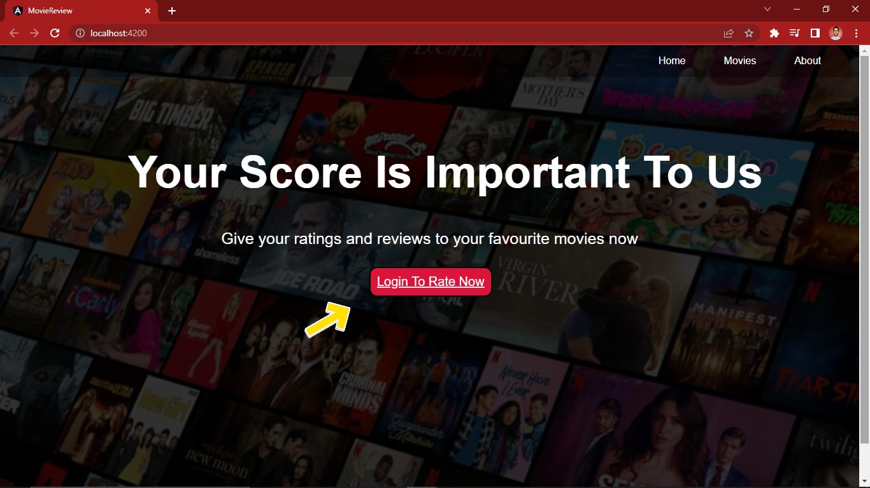

**Step 2) Firstly Login (if you have an account) Otherwise Signup (for a new account creation).**

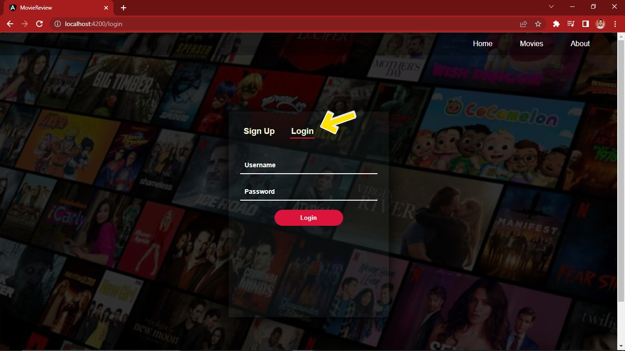

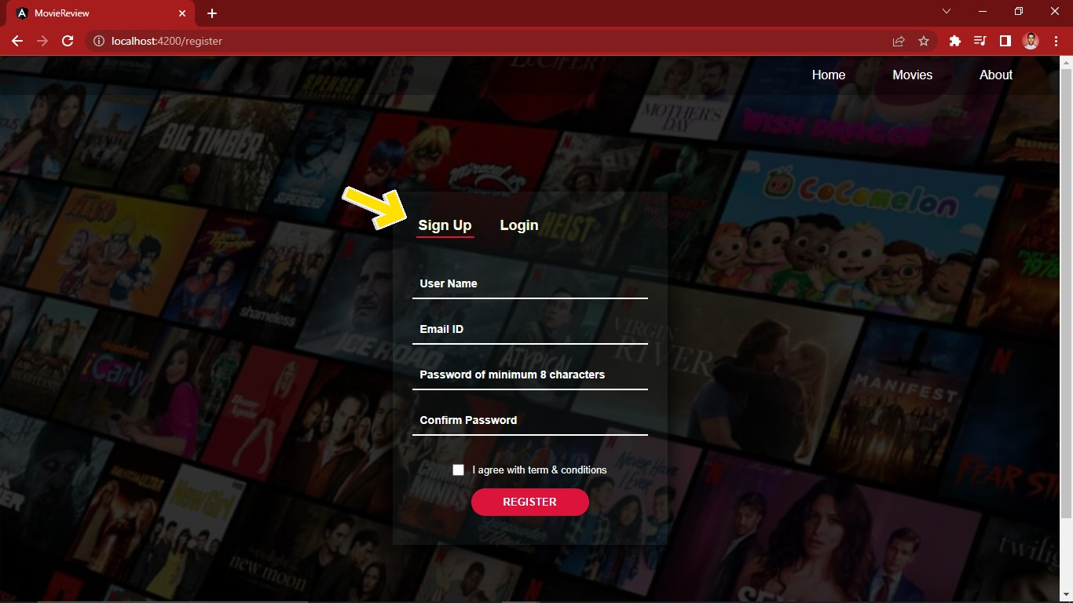

**Step 3) After successfully Login, select any of the movies/TV Shows from the list that you want to give review.**

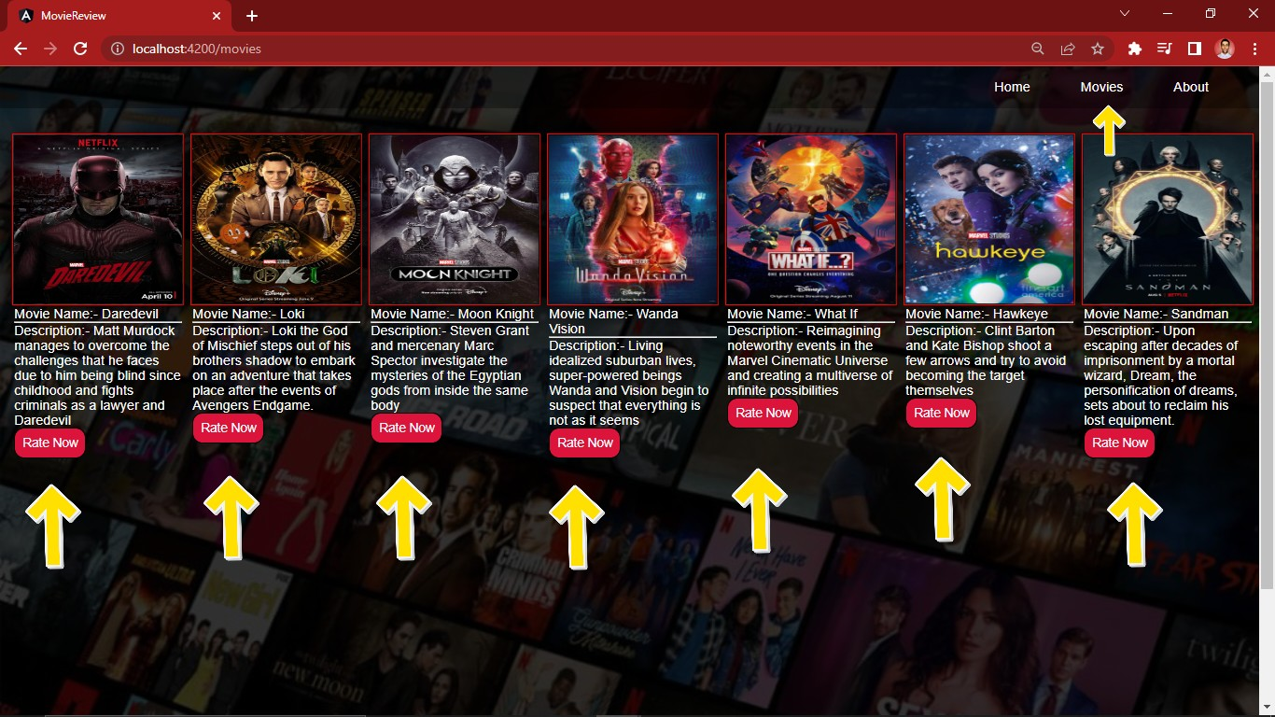

**Step 4) Provide the necessary review from the options provided and rate accordingly.**

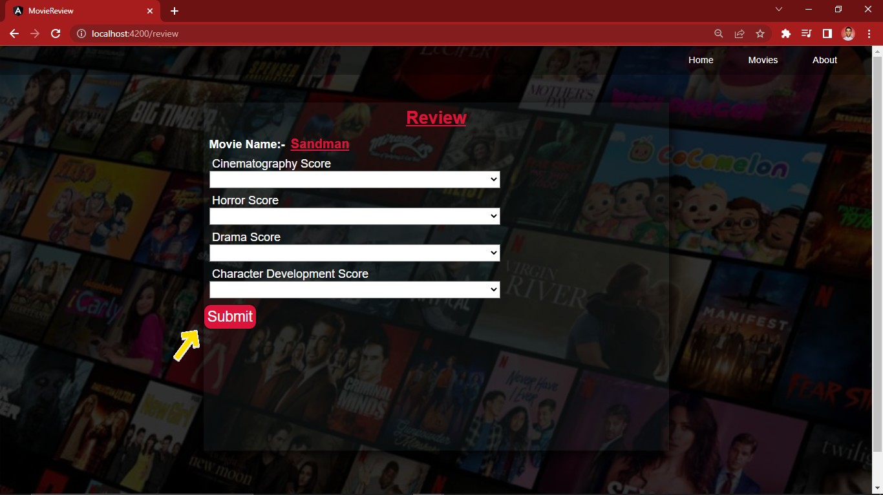

**Step 5) To learn/ know more about the creators of this application, kindly visit the About section.**

